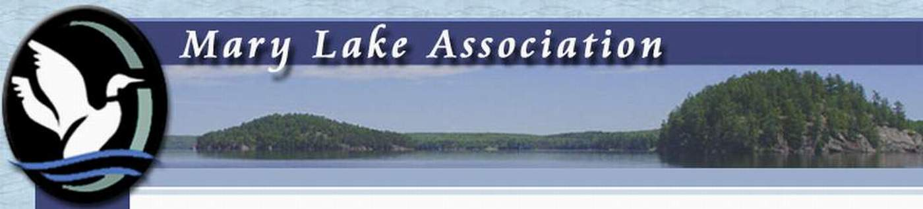MEMBERSHIP INVOICE
MARY LAKE ASSOCIATION
PLEASE FILL IN THE CONTACT INFORMATION BELOW AND CHOOSE:
I-SEND IN BY EMAIL & SEND INTERACT PAYMENT - FOLLOW DIRECTIONS
OR
2-MAIL IN COMPLETED FORM AND PAYMENT TO:
MARYLAKE ASSOCIATION, 105 FITZGERALD DR. RR#3 UTTERSON POB 1MO
OR
3-BRING FORM AND PAYMENT TO AGM
------------------------------------------------------------------------------------------------------------
NAME…………………….. …….………………………………………………………..
CITY ADDRESS………………………………………………………………………….
………….. …………………………………………………………………………………
LOCAL ADDRESS.………………………………………………………………………
……………………………………………………………………………………………..
PHONE ……………………………………………………………………………………
EMAIL….…………………………………………………………………………………
DUES/AMOUNT REMITTED: 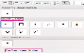 $ 40.00 FOR ONE-YEAR MEMBERSHIP
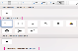 $ 100.00 FOR THREE-YEAR MEMBERSHIP
---------------------------------------------------------------------------------------------------------
INTERACT DIRECTIONS: - PLEASE CREATE:
- INTERACT SECURITY QUESTION;…………………………………………………
- INTERACT ANSWER…………………………………………………………………
- (ONLY FOR INTERACT PAYMENTS)FORWARD THIS COMPLETED FORM TO:
MARYLAKEASSOCIATIONTREASURER@GMAIL.COM

NEXT AGM July 11, 2020 Port Sydney Community Hall 9 am

